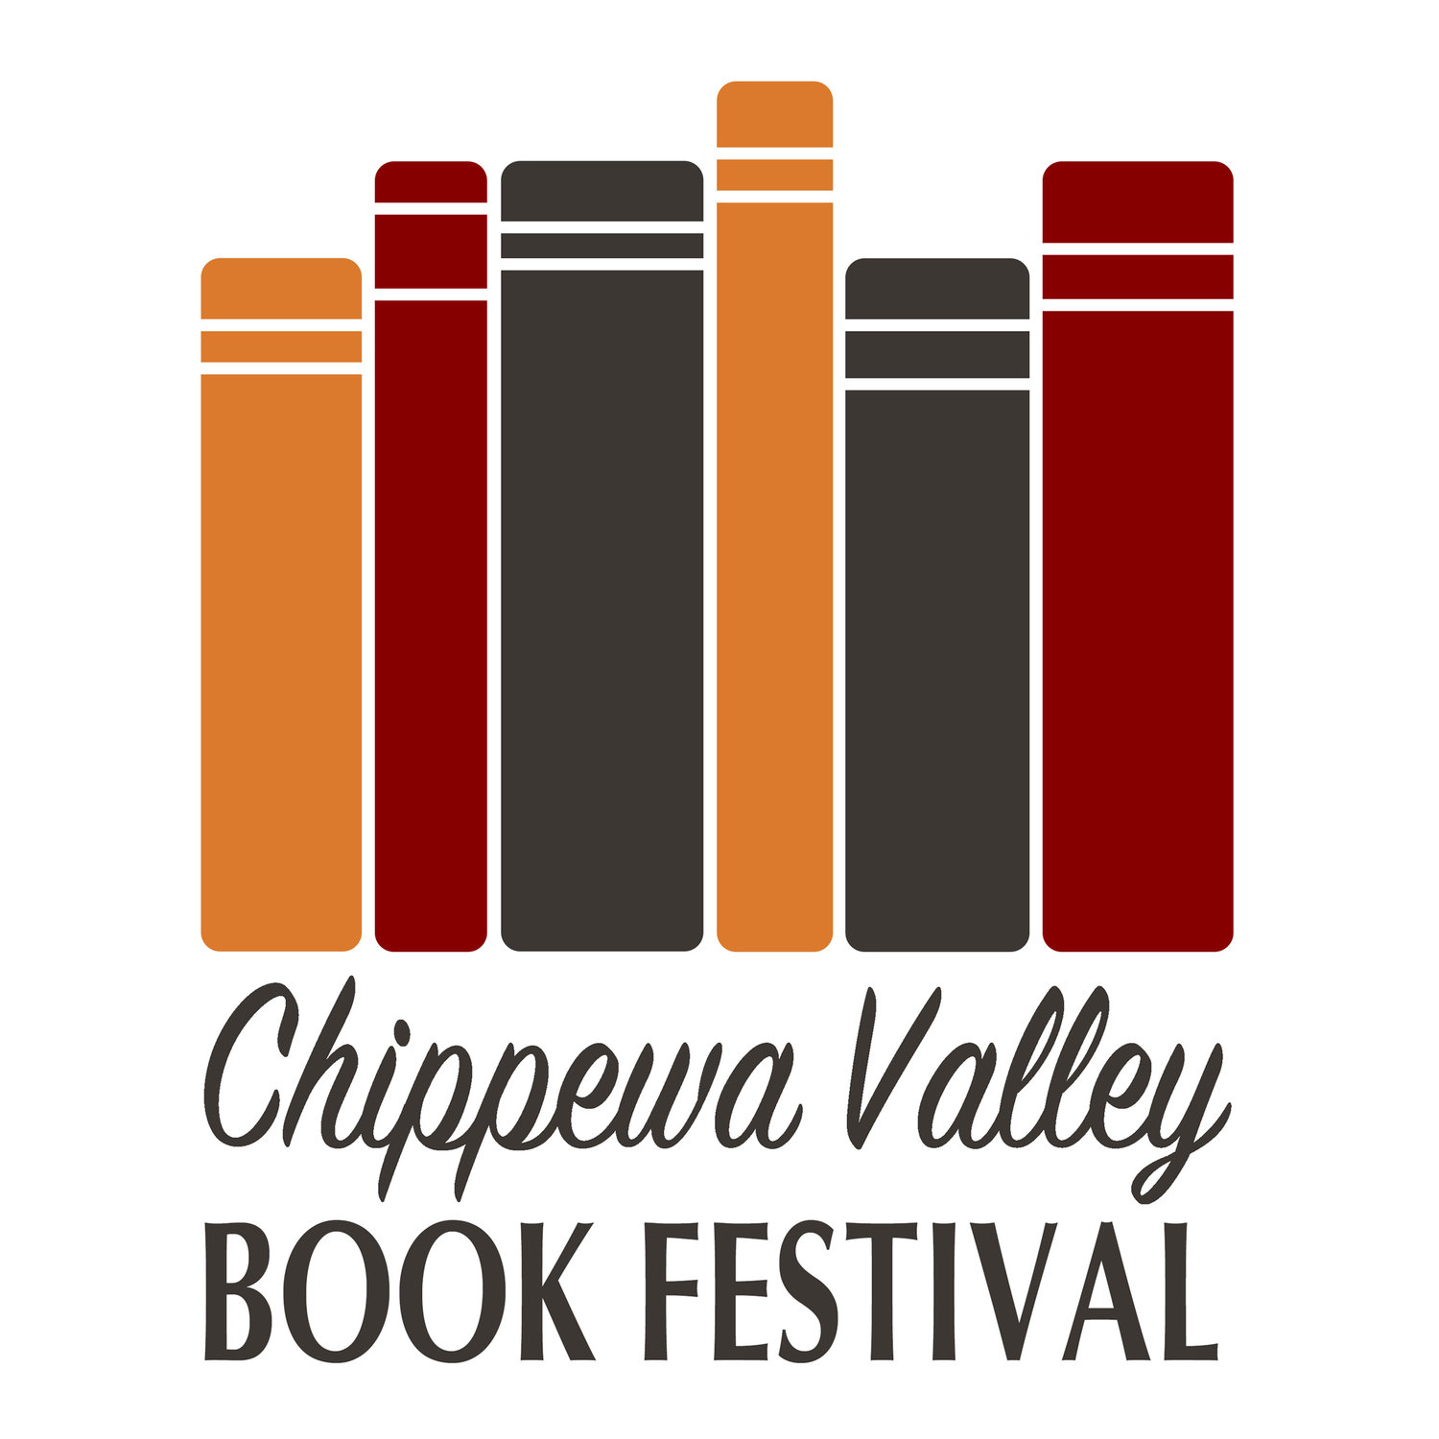
Judy Dekan, Co-Coordinator, Chippewa Valley Book Festival
jdekan@aol.com
FOR IMMEDIATE RELEASE
Eau Claire, WI – June 4, 2018

19th Annual Chippewa Valley Book Festival unveils new brand
The Literary Arts Committee of the Eau Claire Regional Arts Council launched the organization’s visual rebrand on June 1, 2018, including the unveiling of the newly built and reimagined cvbookfest.org. New elements of the Chippewa Valley Book Festival’s rebrand consist of an updated new logo design, tagline, and website, all inspired by the organization’s goal to expand their audience and build their visibility as the festival nears its 20th year.”
The Chippewa Valley Book Festival will be hosting the 19th Annual Chippewa Valley Book Festival October 15 – 25, 2018 across the Chippewa Valley. Holding dozens of events throughout the Chippewa Valley over 10 days, we are thrilled to announce that some events will be taking place at the new Pablo Center at the Confluence. Events consist of readings, book discussions, workshops, author receptions, a dinner-with-the-author event, and youth programs.
The Chippewa Valley Book Festival partners with area libraries and school districts, the University of Wisconsin-Eau Claire, the Chippewa Valley Technical College, and the Chippewa Valley Museum. The festival exists due to the local support of area businesses and individuals.
Since 2000 the festival has hosted over 320 writers. Among them have been such nationally known writers as Ayad Akhtar, Charles Baxter, Christina Baker Kline, Nickolas Butler, Matthew Desmond, Naomi Shihab Nye, Hillary Jordan, local writers such as Karen Loeb, John Hildebrand, Michael Perry, and BJ Hollars. Our annual poetry conversation has included Wisconsin Poet Laureates Karla Huston, Kimberly Blaeser and Max Garland.
The festival, which began in 2000, has evolved into a dynamic 7-10 day event, offering a variety of programs promoting reading and writing. Nearly 5,000 attendees participate in festival events annually, which include options for youth as well as adults. The positive image and family-friendly activities associated with the festival also benefit area libraries, bookstores, businesses and the local arts scene. See our website and Facebook page for the most up to date information on events and authors.

###

